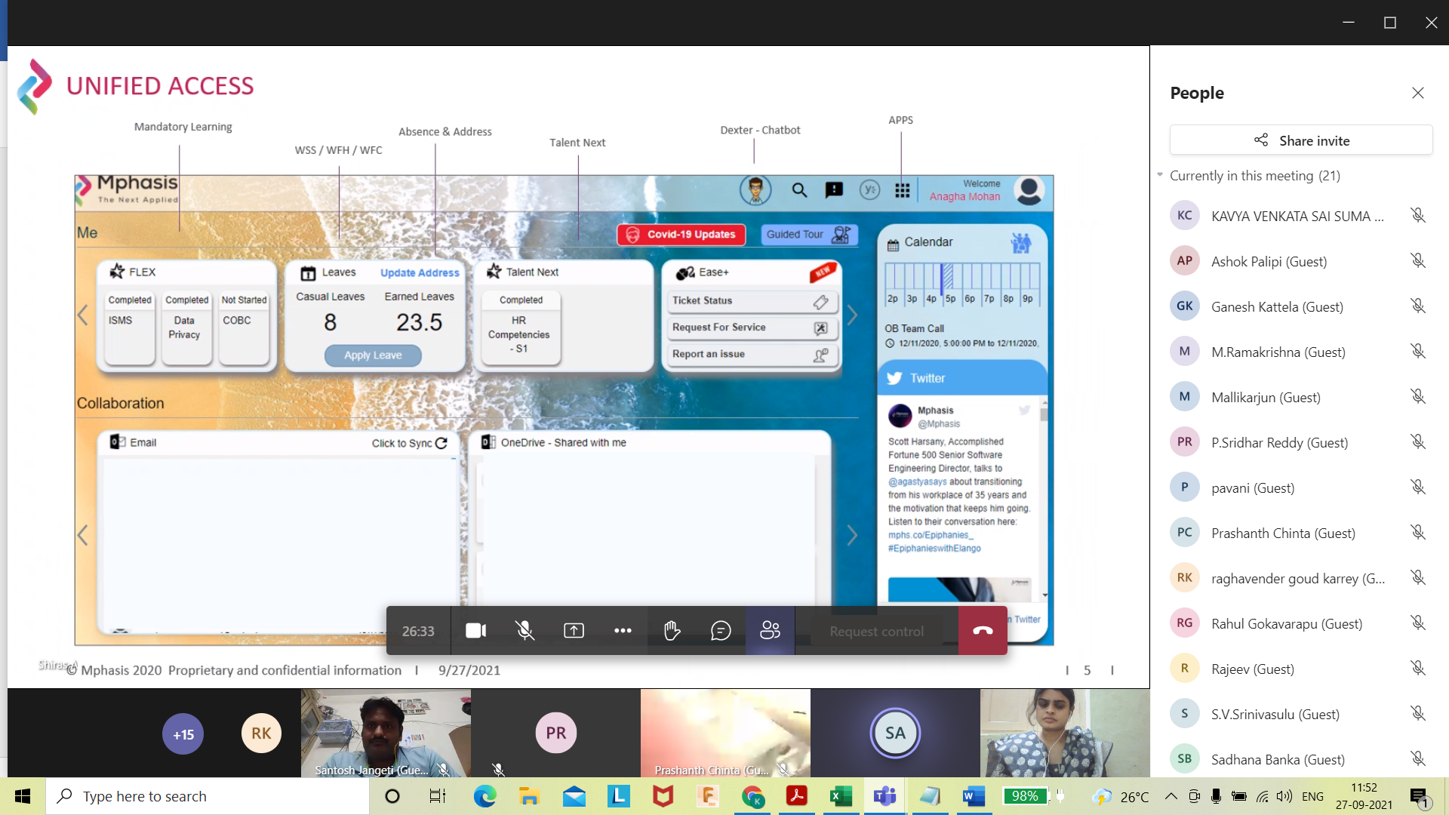

Ease team for login issues



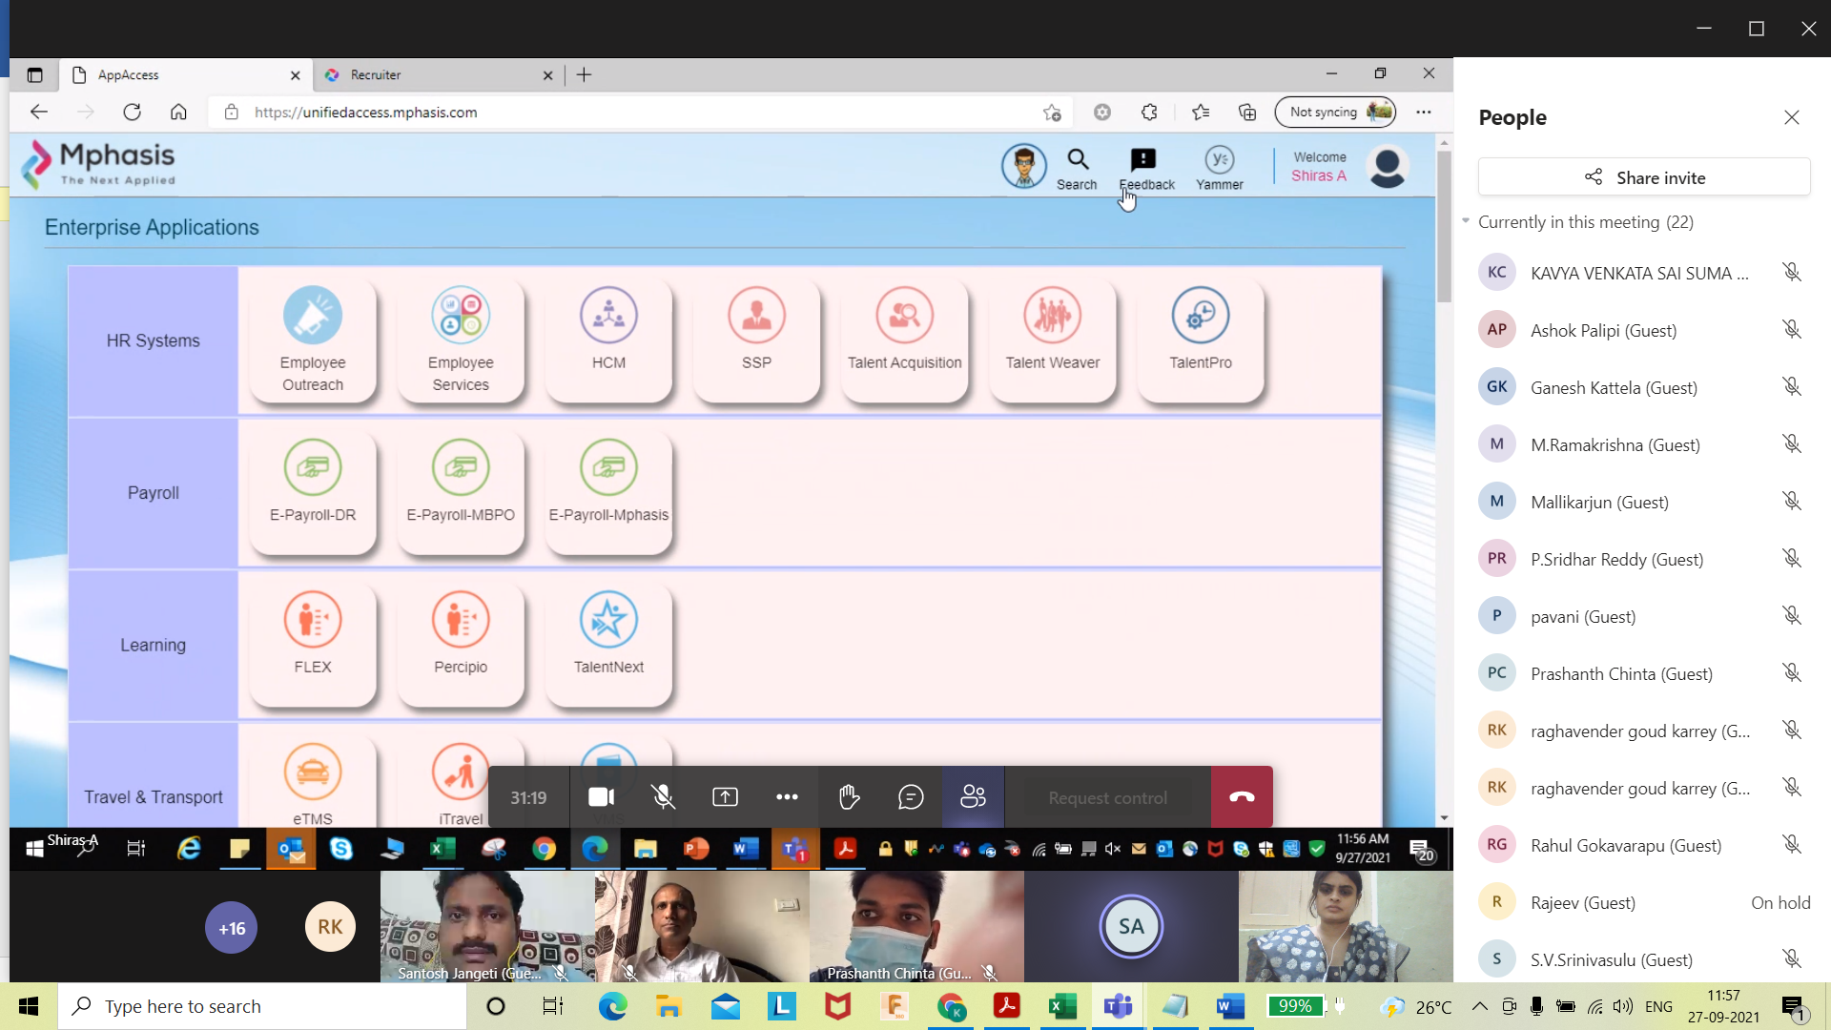

Employee outreach – add attendance

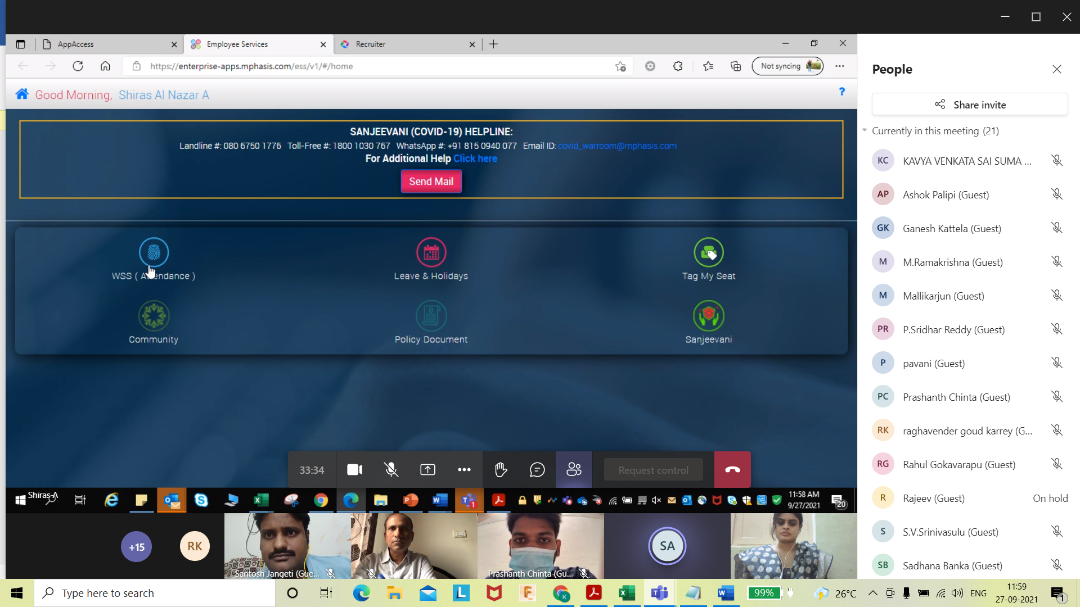

Ask manager to mark work from home in advance for specific days

Bank Account updation- HCM—open an HDFC Account help from Bank SPOC-New employee into Mphasis

SSP- self service portal  
  
Flex—DO Mandatiry courses(complete before 30 days)

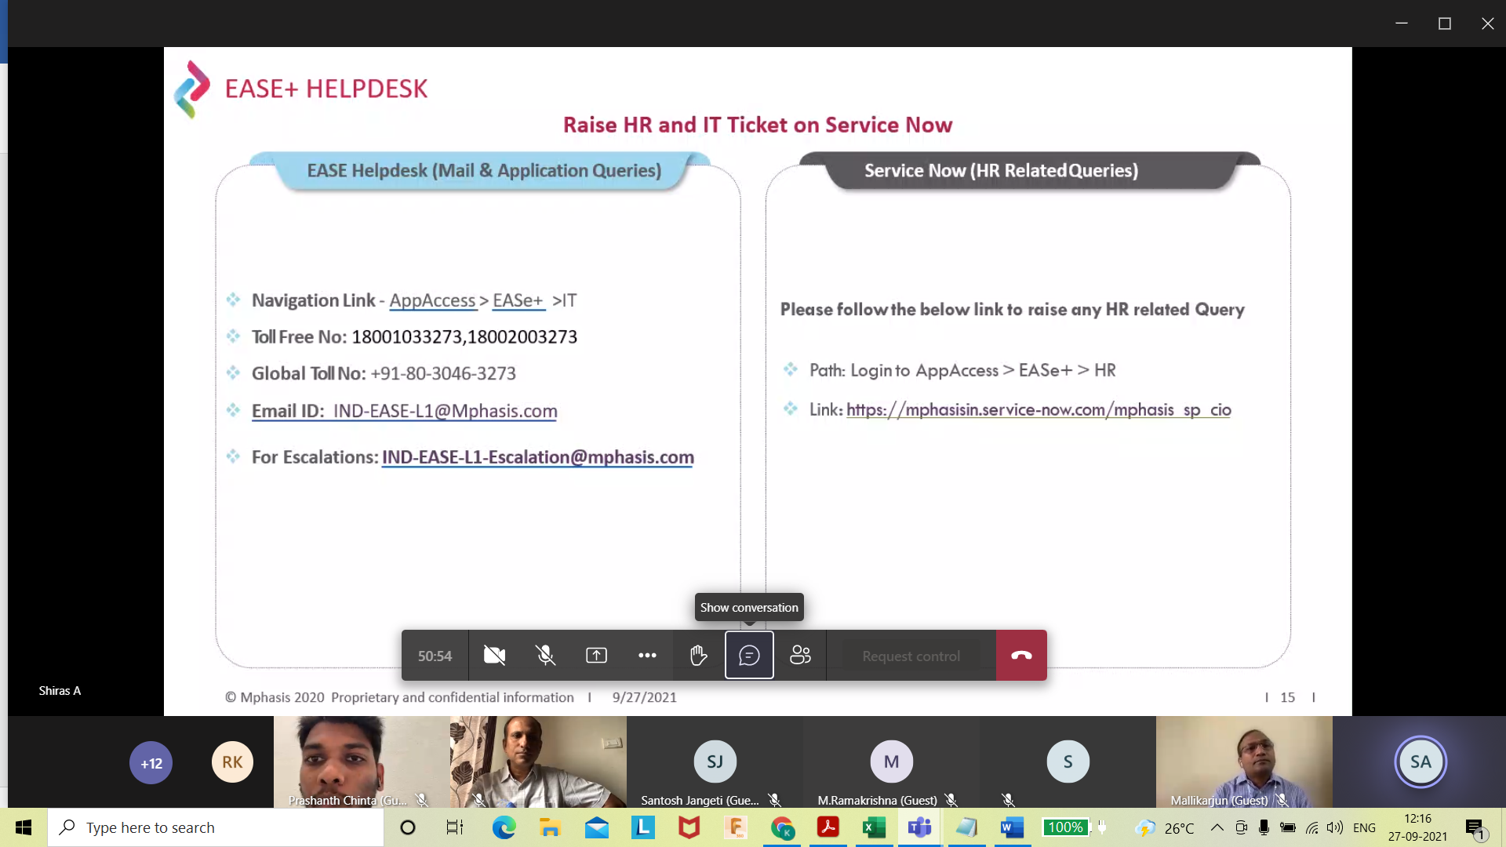

Dexter- chat BOTS—for any help

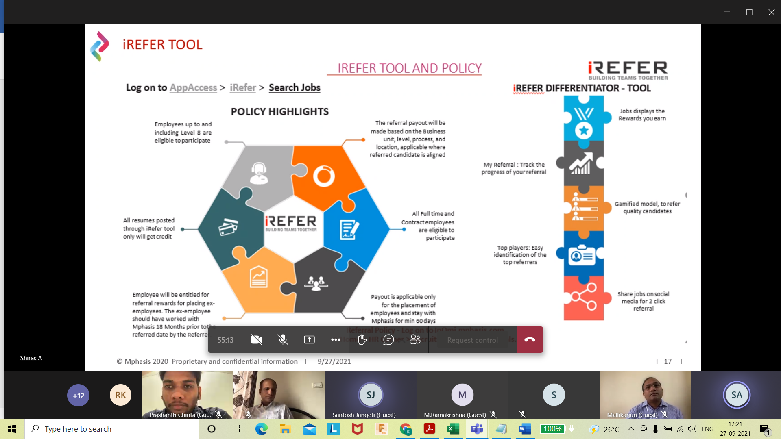

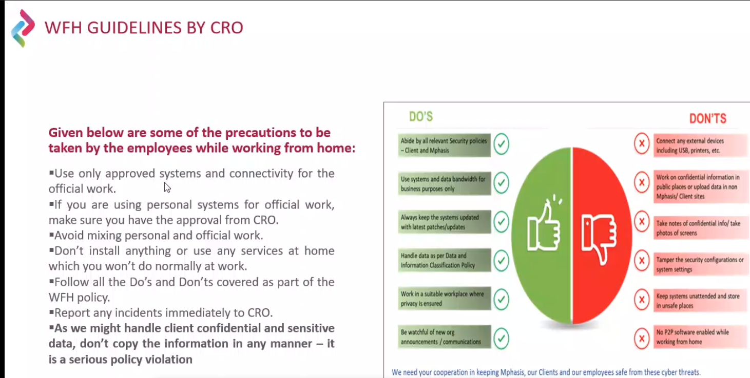

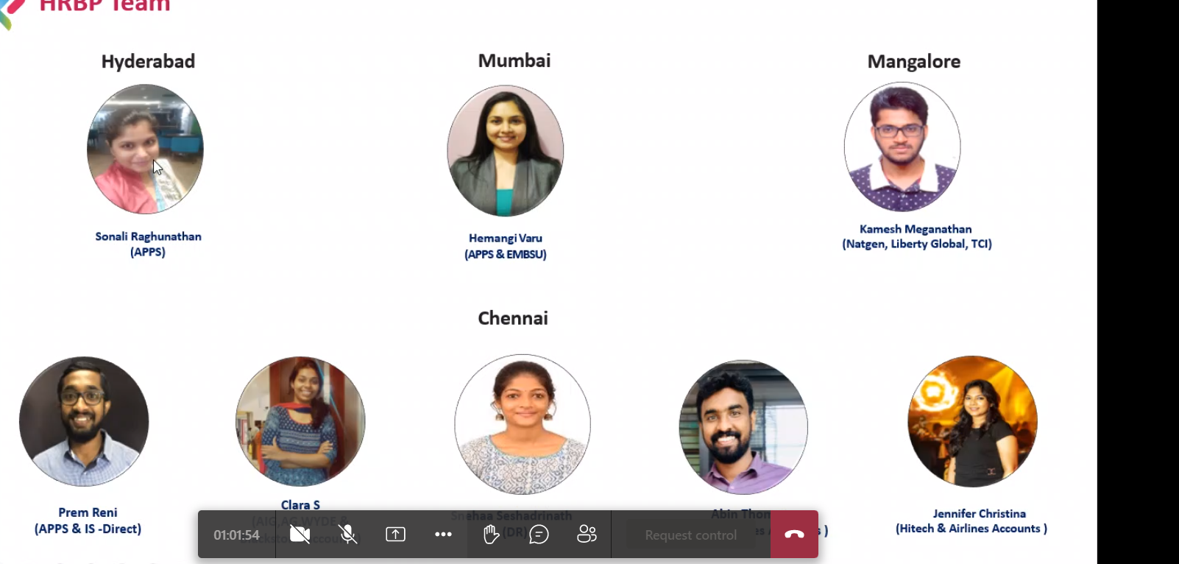

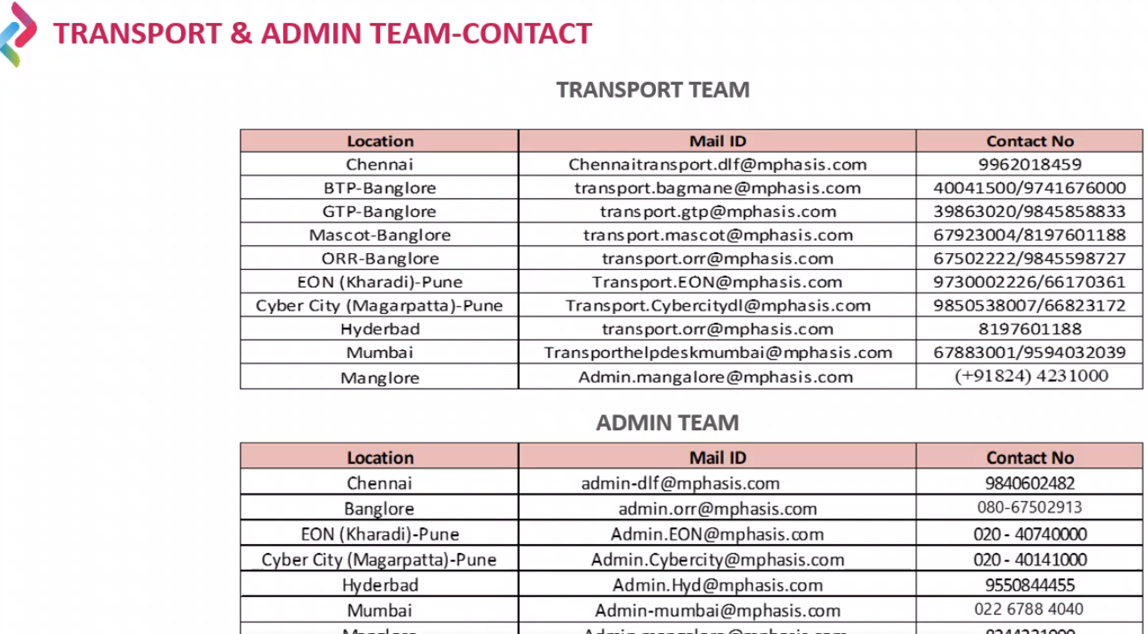

ETMS- daily pick up &drop- Cab facility

Request laptop in EASE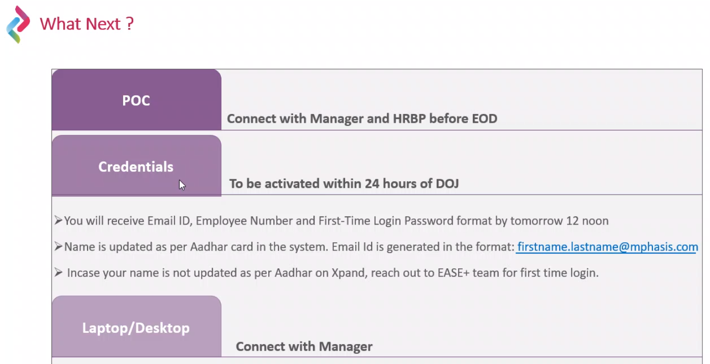

IndiaMail- form mphasis mail logon